UNIVERSITY OF WATERLOO
Software Engineering

Preliminary robotics design report on Calibration, Movement, and Sensors

Professor Billy Bishop, Electrical and Computer Engineering
University of Waterloo
Waterloo, Ontario, N2L 3G1

Prepared by
Team 13
Burstyn, Daniel Maximilian
Eshiokwu, Ikechukwu
Hindson, Douglas
Kendle, James
Liu, Ruich
Phan, Matthew
Sharma, Saumaya
Thai, Lisa
Xie, Karen Jie Ru
1A Software Engineering
Nov, 7, 2006
November 9, 2006

Dr. W. D. Bishop
SE 101 Course Instructor
University of Waterloo
Waterloo, ON N2L 3G1

Dear Prof. William David Bishop:

The report attached is entitled “Preliminary robotics design report on Calibration, Movement, and Sensors” and it is based on our 1A software engineering project. The project is to program a LEGO® Robot to follow a maze. The software that is required to be used is leJOS and the program should be built as an event-driven program.

Our project team name is “13-37” and we consist of two main groups; coders and writers. In brief description, the coders are broken down into two categories of motion and calibration. The writers are to work on the preliminary report, record the team’s progression on the project, and to write the final report.

The preliminary design report will consist of a Gantt chart, introduction of the project, and a summary of design teams. The Gant chart will describe the timeline and progression of our project. Since this is not a final report, there will not be any technical details or any information viewed from an engineering perspective.

We as a team confirm that we received no help in writing this report. We also confirm that this report has no been previously submitted for an academic credit at this or any academic institution.

Sincerely,
Team 13-37
i
Table of Contents

List of Figures...............................................................................................................iii

- Introduction...............................................................................................................1
- Team Description ..3
- References……………………………………………………………………….....5

ii
List of Figures

Figure 1: Gantt Chart of Project Timeline 4

iii
INTRODUCTION
This fall 2006 term, Team 13-37 aims to program a LEGO® robot that will run through a designated course the quickest out of fifteen other groups. We will accomplish this by using a LEGO® software program called leJOS to maneuver the robot based on what the sensors read. Additionally, by breaking up our team into smaller groups, recognizing what the programmers need to accomplish, and frequent communication with other members, we are confident that we will have a great outcome in the completion of our robot.
In order to maintain productivity, our team has been split into two subgroups; programming and technical writing. Each member is assigned to a group and is given a specific task based on their strengths and weaknesses. Therefore, we are able to maximize our efficiency by allowing those knowledgeable in programming to focus only on that aspect and not on their technical writing skills, and vice versa. This will allow us to not only have the robot finished in time, but to also allow further testing of the robot and check spelling and grammar of the technical write-ups.
Specifically, the programming subgroup recognizes several issues that are to be resolved before any progress can be made. These include the compilation of leJOS onto several personal laptops, understanding how to use the RCX brick and creating a version control system. The latter would allow our group to perform simultaneous development on source code files, archive differences in source code files to allow restoration of a previous version, and force the documentation of changes to source code. Also, this permits our programmers to work on the same code file simultaneously in an organized fashion.
However, the main challenge for the programming subgroup is the coding of the LEGO® robot itself. The group must agree on and design a Java program that will consider sensor placement and a turning method of the robot. This will be accomplished through brainstorming, brain writing and compromise of disagreements.

1
There are many details included in this design report. An example is the summary of the design teams. The summary includes a description of the team members and the tasks that they are expected to complete. The Gantt chart is a very important part of this report, which shows the timeline of our project. It describes how long each segment of the project will take to complete. Furthermore, it allows us to see if everything is going according to schedule. If it is not, then we can try to resolve the causes of the delay. Without the chart, the entire project would be more difficult because we would not know which parts should be complete during any given time. Finally the references section of this report lists, using the MLA format, the resources that we used to complete this design report and the code that makes the robot move.
Finally, our strong communication plays a key role in the success of our team. In order to eliminate procrastination, we hold meetings every Tuesday morning in order to discuss about any problems or solutions that we have come across. Furthermore, we have created a Gantt chart which divides our project into a series of smaller tasks. This will let us know exactly what tasks need to be accomplished, and also when they should be completed.

2
TEAM DESCRIPTION

Our team consists of nine people, and they are: Max Burstyn, Ikechukwu Eshiokwu, Douglas Hindson, James Kendle, Ruichi Lui, Matthew Phan, Saumaya Sharma, Lisa Thai, and Karen Xie. Arranging meetings outside of class will be fairly challenging, so we have decided to split the team into two sub-teams. This greatly makes it easier to arrange sub-team meetings, and it also gives everyone a designated task to complete. The first sub-team is dedicated to writing the project deliverables and it consists of Ruichi, Matthew, Saumaya, Lisa and Karen. The second sub-team consists of four people, who are responsible to program and test the robot. This team is made up of Max, Ikechukwu, Douglas and James.
The members on the technical writing team work on the documents that are to be submitted. These members also take notes during each meeting, which describe possible problems that were encountered and how they were resolved. They also record the results from testing the robot and any new ideas that arise from the testing. These notes will also be used in the final report. Each person on the technical writing team has a designated task for each project deliverable. These tasks are based on the required components for the reports.
The coding team is further separated into two teams, having two members each. The first team is dedicated to programming the calibration of the sensors. This sub-team consists of Ikechukwu and James. The second team is dedicated to programming the robot to move using the sensor readings. This sub-team consists of Max and Douglas. The majority of the robot testing will be done by the coding team because they are the ones who will have the best understanding of the programming.
Although the team is split in two for each type of task, all team members participate in discussions concerning the general robot design. Some discussion topics include: whether the robot will move forward or backwards; the speed that the robot will move at; how the robot will turn, etc.

3
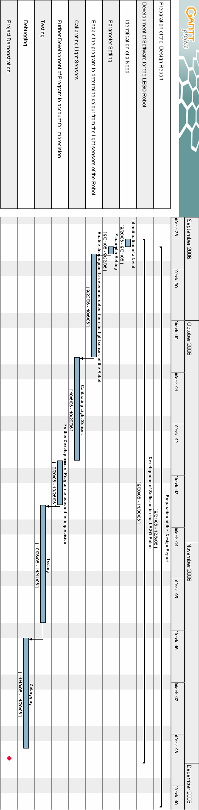
4

References:

Scholz, Matthias Paul , Bagnall Brian, Griffiths, Lawrie.
Lejos Tutorial: A practical guide for developers. 2 Nov. 2006 http://lejos.sourceforge.net/tutorial/

GanttProject. Vers. 2.0.2 . Online. 3 Nov 2006.
http://ganttproject.sourceforge.net/

USB Tower Drive Vers. 1.64 . Online. 11 Oct 2006 http://www.lego.com/eng/education/mindstorms/home.asp?pagename=download

5

